Title: The Unbroken Chain of the Central Highlands: From Mount Harā Bərəzaitī (Gar) to Gharjistan, Zabulistan, and Hazarajat (Āzrah-jat)
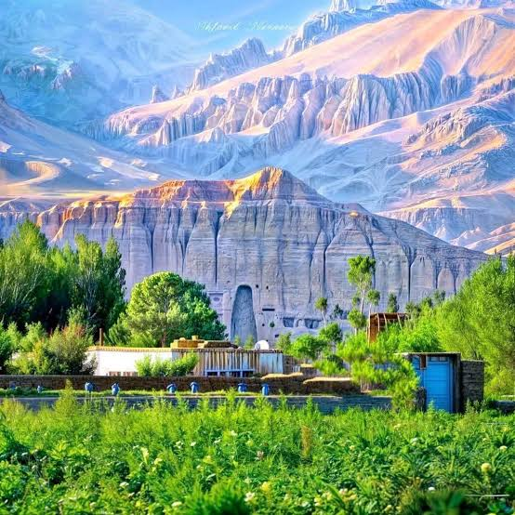
Abstract

This article examines the unbroken linguistic, geographical, and mythological chain that connects the sacred Avestan mountain Harā Bərəzaitī (the guardian mountain) to the modern region of Hazarajat (Āzrah-jat) in the central highlands of Afghanistan. The evidence establishes a continuous toponymic and civilizational sequence. The ancient Iranian root "Gar" (mountain/guardian) gave rise to the name Garshestan (Gharjistan), designating the sacred highlands of Airyanem Vaejah. This mountainous core corresponds geographically to Zabulistan, the epic homeland of the House of Nariman (Sām, Zāl, and Rostam). In the modern era, this same territory is known as Hazarajat and Āzrah-jat, preserving the Avestan name Arəzahī. The indigenous Āzrah population, carrying the Neolithic Iranian lineage J2a1-Page55, are the direct inheritors of this sacred and epic landscape. The later name "Sistan" (derived from Sakastan) represents a late and superficial overlay imposed by Scythian populations centuries after the formation of the Iranian epic tradition.

1. Introduction

The sacred geography of ancient Iran possesses an unbreakable bond with the central highlands of Afghanistan. In Avestan texts, Mount Harā Bərəzaitī is identified as a cosmic, sacred, and guardian mountain encircling the world and serving as the source of all other mountains. Contemporary historical-geographical research identifies this mythological mountain with the central highlands of Afghanistan, specifically the peak known today as Mount Baba. This article demonstrates that the historical names of this region—Garshestan, Gharjistan, Zabulistan, Hazarajat, and Āzrah-jat—are not separate labels. They form an unbroken chain of identity rooted in the Avestan concept of the "guardian mountain" (Gar).

2. Mount Harā Bərəzaitī (Gar) and Mount Baba: The Sacred Center

Mount Harā Bərəzaitī in the Avesta (Yasht 19) functions as both a geographical entity and a theological concept. This mountain symbolizes the stability and protection of the Aryan land against the forces of darkness (Steppe invaders/Turānians). The identification of this mountain with Mount Baba in the central highlands of Afghanistan is established through climatic and textual evidence. Mount Baba is the highest peak in central Afghanistan and the source of the Helmand, Hari Rud, and Murghab rivers. This "source" characteristic aligns perfectly with the Avestan description of Harā Bərəzaitī as the "mother of mountains." Mount Baba is the guardian mountain of Airyanem Vaejah. The ancient Iranian root "Gar" (mountain/guardian) originates from this sacred peak.

3. From Gar to Garshestan and Gharjistan

The name Gharjistan represents a corruption of the term Garshestan. The root of this name is the Avestan word "Gar", meaning "mountain" and "guardian." This root originates directly from the name of the sacred mountain Harā Bərəzaitī.

· In the ancient Hazaragi (Āzragī) dialect, the word "Giro" meaning mountain preserves this Avestan root "Gar."
· Islamic geographers (such as Muqaddasi) recorded that the word "Gharj" meant "mountain" in the local language and that the title of local kings was "Shar." Therefore, "Gharj al-Shar" translates to "Mountain of the King."
· The name "Gharjistan" was applied to the entire territory of Airyanem Vaejah due to the presence of these immense and sacred mountains. This name stands as a living document of the region's unbreakable connection to the sacred mountain Harā Bərəzaitī.

4. Zabulistan and Sharistan: The Epic Homeland

The region of Gharjistan formed the mountainous heart of the broader territory known in the Iranian epic tradition as Zabulistan. The epic cycle of the House of Nariman (the lineage of Sām, Zāl, and Rostam) was fully formed in the Late Bronze Age and Early Iron Age (c. 1500–1000 BCE). The geographical core of this tradition lies precisely in the highlands of Sharistan (modern Daykundi) and the surrounding mountainous districts of Gharjistan.

· Ferdowsi's Shāhnāmeh references the region under the name Gharchegan, a variant of Gharjistan. In the narrative of the Eleven Battles (Yāzdah Rokh), Piran Viseh proposes the demarcation of the Iran-Turan border: "From Iran, I will first enter the mountain, in Gharchegan up to the land of Bast."
· The "King of Gharchegan" (Shah-e Gharchegan) is named as a commander who fights "like a lion." The epic tradition thus anchors the heroic geography of Zabulistan in the highlands of Gharjistan, centuries before the arrival of the Saka.

5. Hazarajat and Āzrah-jat: The Living Continuation

The toponymic chain extends into the modern era. The territory of ancient Gharjistan and Zabulistan is known today as Hazarajat and Āzrah-jat. The name Āzrah derives directly from the Avestan Arəzahī, the "eastern clime of light" and a sacred region within Airyanem Vaejah.

· The population of this region, the Āzrah (Hazaras), carries the Neolithic Iranian farmer lineage J2a1-Page55 at a frequency of 13%, while the Steppe lineage R1a-Z93 is present at only 6.67% (Haber et al., 2012; Di Cristofaro et al., 2013).
· The Āzrah preserve 25–35% of the core Avestan lexicon in their Hazaragi dialect. The words Giro (mountain) and Āzrah (the endonym) are living linguistic fossils of the Avestan heritage.
· The data establishes that the Āzrah are the direct inheritors of the sacred geography of Mount Harā Bərəzaitī, Garshestan, Zabulistan, and Sharistan. The chain remains unbroken.

6. The Late Overlay: From Zranka to Sakastan and Sistan

The name "Sistan" is a late and corrupted label that breaks the indigenous chain of identity. The original Old Persian name for the territory corresponding to Sistan was Zranka (Greek: Drangiana). The Saka (Scythians), carrying the Steppe lineage R1a-Z93, migrated into the Helmand basin only in the 2nd century BCE. Their presence gave rise to the name Sakastān ("Land of the Saka"), which the Arabs later transformed into Sijistan and then Sistan. The name Sistan, therefore, postdates the formation of the Zabulistan epic tradition by over a thousand years. It is a superimposed military and linguistic layer upon the indigenous civilizational foundation of Gharjistan and Hazarajat.

7. Conclusion

The linguistic, geographical, and genetic evidence establishes an unbroken chain of identity in the central highlands of Afghanistan. Mount Harā Bərəzaitī (the guardian mountain, Gar) gave its name to Garshestan (Gharjistan). This mountainous core formed the epic homeland of Zabulistan and the House of Nariman. The territory is known today as Hazarajat and Āzrah-jat, preserving the Avestan name Arəzahī. The Āzrah population, carrying the Neolithic J2a1 lineage and preserving Avestan linguistic elements, are the indigenous custodians of this sacred landscape. The name Sistan (Sakastan) represents a late Scythian overlay that must not obscure the authentic chain of Gharjistan, Zabulistan, and Hazarajat.

References

1. Haber, M., et al. (2012). Afghanistan's Ethnic Groups Share a Y-Chromosomal Heritage Structured by Historical Events. PLOS ONE, 7(3), e34288.
2. Di Cristofaro, J., et al. (2013). Afghan Hindu Kush: Where Eurasian Sub-Continent Gene Flows Converge. PLOS ONE, 8(10), e76748.
3. Witzel, M. (2000). The Home of the Aryans. Harvard University.
4. Ferdowsi, A. Shahnameh (References to Gharchegan and Zabulistan).
5. Cohistani, B. (2026). The Legendary House of Nariman: Zabulistan, Zranka, and the Enduring Epicenter of Iranian Heroic Tradition. Zenodo.

